NAME : KOVI SAI GANESH

REGISTER NUMBER : 192124028

COURSE CODE : CSA0520

COURSE NAME : DATABASE MANAGEMENT FOR DATA ANALYTICS

***1Q.DDL Commands-(Create,Alter,Drop)***

mysql> CREATE TABLE Student

-> (Std_ID int(5),

-> std_Name char(20),

-> Gender char(5),

-> Phone int(15),

-> DOB date,

-> Department char(20));

Query OK, 0 rows affected (0.11 sec)

mysql> desc Student;

+------------+----------+------+-----+---------+-------+

| Field | Type | Null | Key | Default | Extra |

+------------+----------+------+-----+---------+-------+

| Std_ID | int(5) | YES | | NULL | |

| std_Name | char(20) | YES | | NULL | |

| Gender | char(5) | YES | | NULL | |

| Phone | int(15) | YES | | NULL | |

| DOB | date | YES | | NULL | |

| Department | char(20) | YES | | NULL | |

+------------+----------+------+-----+---------+-------+

6 rows in set (0.01 sec)

mysql> ALTER TABLE Student

-> ADD COLUMN Year int(5);

Query OK, 0 rows affected (0.15 sec)

Records: 0 Duplicates: 0 Warnings: 0

mysql> desc Student;

+------------+----------+------+-----+---------+-------+

| Field | Type | Null | Key | Default | Extra |

+------------+----------+------+-----+---------+-------+

| Std_ID | int(5) | YES | | NULL | |

| std_Name | char(20) | YES | | NULL | |

| Gender | char(5) | YES | | NULL | |

| Phone | int(15) | YES | | NULL | |

| DOB | date | YES | | NULL | |

| Department | char(20) | YES | | NULL | |

| Year | int(5) | YES | | NULL | |

+------------+----------+------+-----+---------+-------+

7 rows in set (0.02 sec)

mysql> ALTER TABLE Student

-> DROP COLUMN Department;

Query OK, 0 rows affected (0.14 sec)

Records: 0 Duplicates: 0 Warnings: 0

mysql> desc Student;

+----------+----------+------+-----+---------+-------+

| Field | Type | Null | Key | Default | Extra |

+----------+----------+------+-----+---------+-------+

| Std_ID | int(5) | YES | | NULL | |

| std_Name | char(20) | YES | | NULL | |

| Gender | char(5) | YES | | NULL | |

| Phone | int(15) | YES | | NULL | |

| DOB | date | YES | | NULL | |

| Year | int(5) | YES | | NULL | |

+----------+----------+------+-----+---------+-------+

6 rows in set (0.01 sec)

OUTPUTS :

1Q. 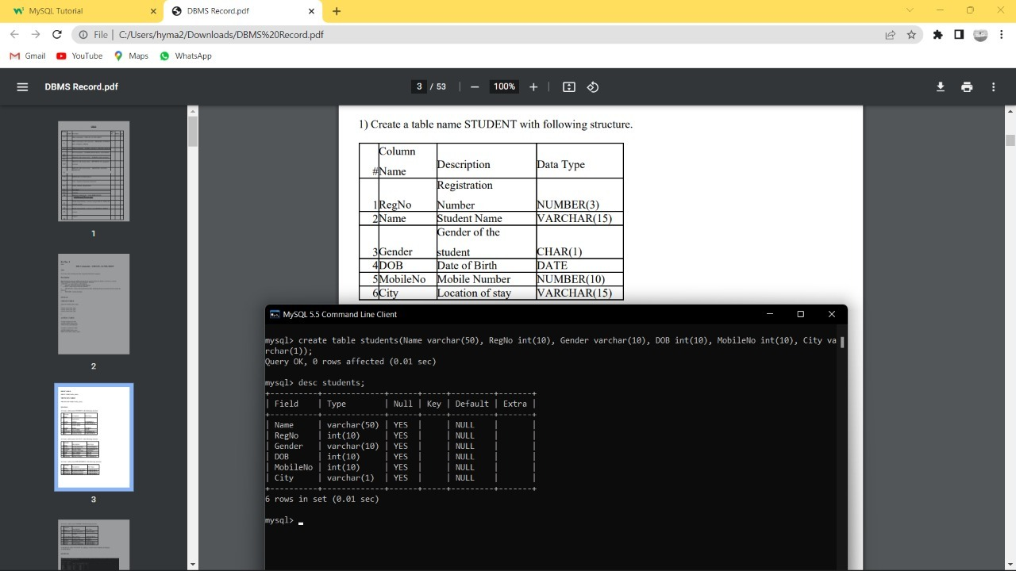

2Q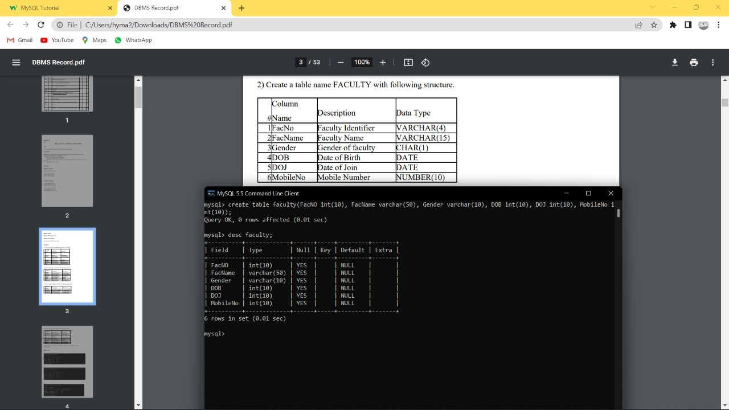

3Q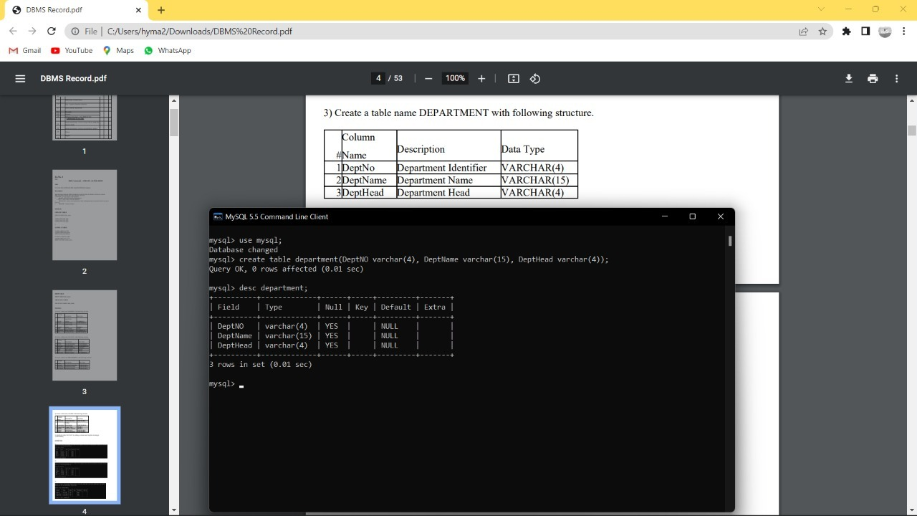

4Q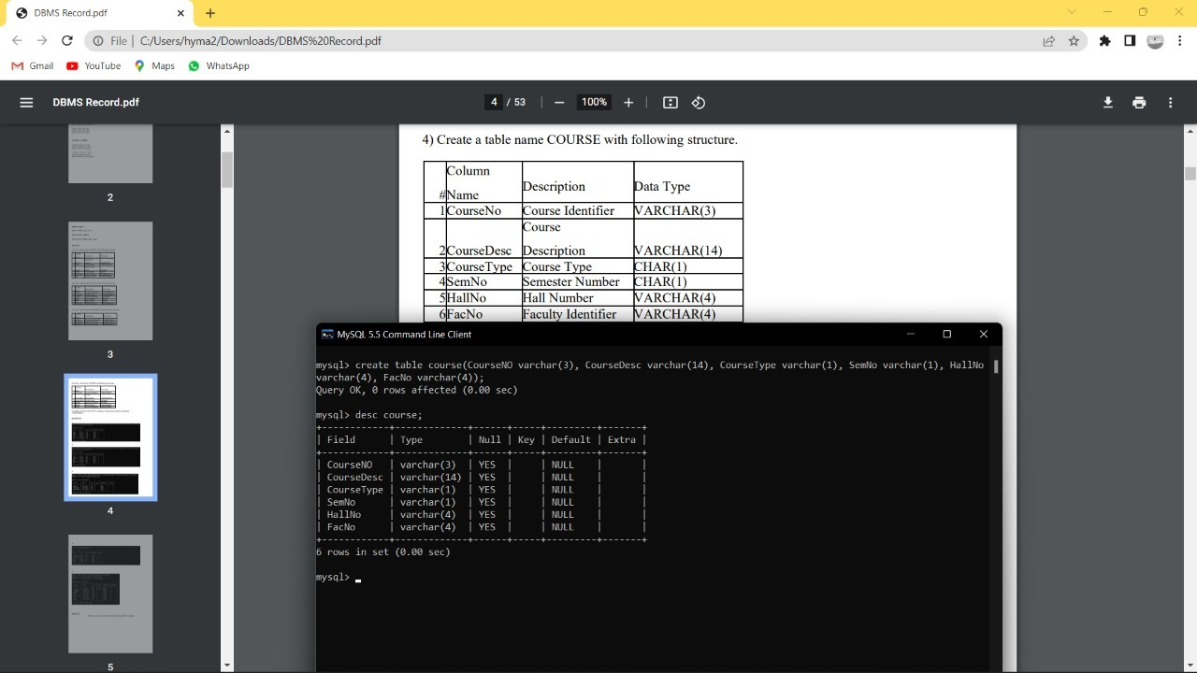

5Q